# Instructions to set up a Gantt calendar SharePoint 365

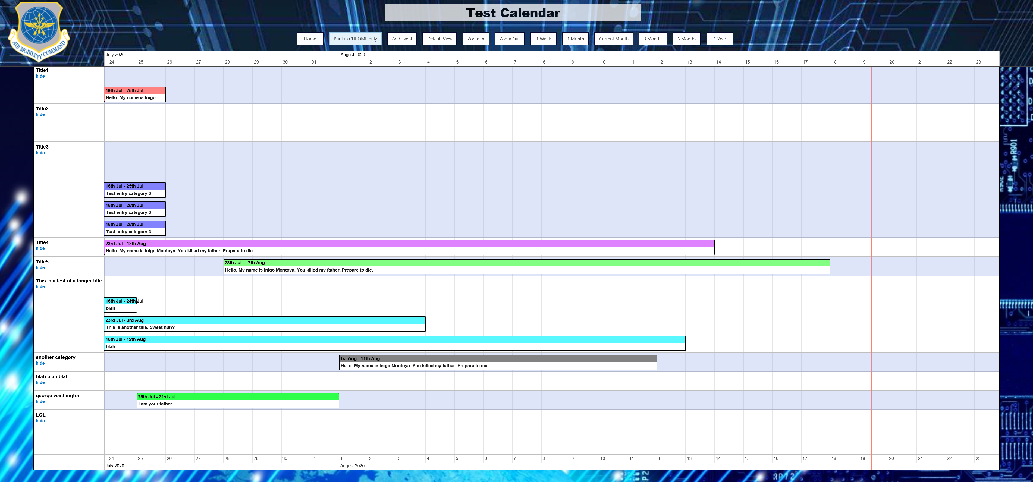

This calendar is to display calendar events as a multiple day event. The left side of the event’s box will align with the Start Date of the event, and the right side will extend to the End Date of the event.

1. Create custom lists for the calendar and categories. Go to the Site Contents through clicking on gear in the top right. Then create a blank list with the New drop down. Note: List names can be anything you want, but column names must be exactly as below!
   1. First, create a custom list to hold the categories for the calendar events with the following columns:

Column Name Column Type Default Value

* + 1. Title Single line text <blank> Standard SharePoint title field
    2. Sort Order Number <blank> Changes display order on calendar
    3. Gantt Color Single line text <blank> Changes background color of header
    4. Text Color Choice (Black or White) Black

Note: The choices for the text color can actually be any text value as seen here: <https://www.w3schools.com/cssref/css_colors.asp>

* 1. Create a custom list to hold calendar data (Note: Not a Calendar List) with the following columns:

Column Name Column Type Default Value

* + 1. Title (mandatory) Single line text <blank> Standard SharePoint title field
    2. Start Date (mandatory) Date <blank> Start date of calendar item
    3. End Date (mandatory) Date <blank> End date of calendar item
    4. Category (mandatory) Lookup Title field of categories list above

NOTE: the Lookup Column type is under “more”. Link the first list you created in the “Get information from” section. Select Title in the “In this column”.

1. Upload the contents of the Scripts folder in this zip file to your Site Assets folder. Do not put it in a subfolder. Note: Example images are included if you would like to use those for you header and page backgrounds as seen in the image above.
2. Update the included MultiDayCalendarGantt.txt file. Note: the automatic links generated by SharePoint 365 will not give you the correct link. See below about links.
   1. Open the text file with a text editor. I suggest Notepad versus Word to avoid any extra formatting caused by Word.
   2. At the top of the file where it says ‘Edit this section’, update the 5 URLs to point to the files that you uploaded to your Site Assets.
   3. Update the two variables with the names of the Calendar list and Categories list that you created previously. You can also modify where the Home button on the calendar redirects to, the default view, the logo, and the backgrounds for both the header and the main body of the page.
   4. Save the MultiDayCalendarGantt.txt file and upload it to the Site Assets as well.
3. Create a page to display the Gantt calendar.
   1. From your Site Contents click on the Site Pages folder.
      1. If the site page folder takes you back you your homepage, make sure the end has …/teams/[unit]/SitePages/Forms/AllPages.aspx
   2. From the menu bar click ‘Files’, then click the dropdown arrow for ‘New Document’ and then select ‘Web Part Page’.
   3. Give the page a Name.
   4. For Page Layout leave it as the default ‘Header, Footer, 3 Columns’.
   5. Click ‘Create’.
   6. Once created click on the Name of the page you created to go to the page.
4. Edit the page to display the calendar.
   1. At the top right of the page click the gear and click ‘Edit Page’.
   2. In the Header section click ‘Add a Web Part’.
   3. Under Categories choose ‘Media and Content’.
   4. Click on ‘Content Editor’ and then click ‘Add’.

Your page should now look something like this:

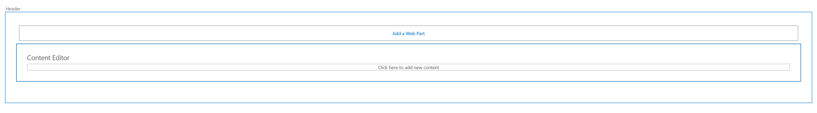

* 1. Edit the Content Editor web part. In the Content Link enter the URL to the MultiDayCalendarGantt.txt file that you uploaded to your Site Assets (i.e. https://eim2.amc.af.mil/Subsite_Name/SiteAssets/MultiDayCalendarGantt.txt). Click OK.
  2. This should load the calendar with some visual glitches.
  3. To fix this issue remove everything after .aspx on the address bar and hit enter. The page should refresh and look correct now.

1. Link information
   1. If you are in your site assets and click the three dot options, you can copy the link. The links created may not work. Those links that have “c:” or “t:” are not correct. You will need to find a “normal” link like the one below to work.
   2. Working link example: <https://usaf.dps.mil/teams/317AirliftWing/SiteAssets/MultiDayCalendarGantt_v2.txt>